**Day 1 Lab Assignments**

**Please do these assignments (Use strict mode in all assignments):**

1. Make function that write “welcome to my page” 6 times using h1 to h6 header sizes using one line (document.Write) JavaScript code “see attached image” . (Use for loop, and don’t use h1 to h6 explicitly)
2. Write a script that takes from the user n values and returns their sum, stop receiving values from user when he enters 0 or sum exceeds 100, check that the entered data is numeric and inform the user with the total sum of the entered values.
3. Write a function that takes 2 parameters: start and end number and print odd numbers between the given 2 numbers.
4. Make a buttons on a page when user clicks it, ask him to enter math expression (Ex. 3+4*5/10*8), and then pass this expression (user input) to a function that take one parameter and execute this expression and then show the result of this expression for the user in an alert in that format: (You entered: 3+4*5, and the result is: 23).
5. On contact page prompt user to enter his name, make sure that name is string, and let the user enter his birth year and make sure that it is a number,, and it is less than 2010 and then calculate his age. For each prompt if user input valid show him next prompt, if not valid show him the same prompt again until user enters it correctly (use loops). And after validating user input, write all user input on the page in that format:

**Name:** ahmed

**Birth year:** 1981

**Age:** 30

1. Try debuggers in the browser and log some debugging messages to the console log.
2. Try lecture example on: Hoisting, let, const.

**Review and test the following:**

1. Try this code using strict mode and without strict mode, what’s the difference? And why?

function foo() {

var x;

x = 5;

y = 6; return x + y;

}

Console.log(foo());//11

1. Will this code work with strict mode? Explain why?

var y;

y=10;

x = 5;

console.log(x); //10

console.log(y); //5

var x;

1. What’s the value of y variable in the following code? And why?

var x = 5;

console.log(x); //5

console.log(y); //undefined

var y = 7;

1. What are the expected errors (2 errors or undefined output) from the following code? And why? What’s the difference between var & let?

function test(){

for (let i = 0; i < 10; i++) {

alert(i);

alert (x);

let x=10;

}

console.log(i);

}

-----------------------------------------------------------------------------------------------------------------------------------------------------------------

**Bonus Assignments:**

1. Write the previous output (Q.4) on a table and create the table on runtime, like this:

|  |  |
| --- | --- |
| **Name** | Ahmed |
| **Birth year** | 1981 |
| **Age** | 30 |

1. Work on the mentioned self-study topics on the lecture slides:
   1. What’s XSS (cross-site scripting)? Cross-site scripting (also known as XSS) is a web security vulnerability that allows an attacker to compromise the interactions that users have with a vulnerable application. It allows an attacker to circumvent the same origin policy, which is designed to segregate different websites from each other. Cross-site scripting vulnerabilities normally allow an attacker to masquerade as a victim user, to carry out any actions that the user is able to perform, and to access any of the user's data. If the victim user has privileged access within the application, then the attacker might be able to gain full control over all of the application's functionality and data.
   2. What are new features in ES6, with demo?

// ES6 syntax

for(let i = 0; i < 5; i++) {

console.log(i); // 0,1,2,3,4

}

console.log(i); // undefined

// ES5 syntax

for(var i = 0; i < 5; i++) {

console.log(i); // 0,1,2,3,4

} console.log(i); // 5

* 1. What’s TypeScript? And what are its new features?

TypeScript adds additional syntax to JavaScript to support a tighter integration with your editor. Catch errors early in your editor.

TypeScript code converts to JavaScript, which runs anywhere JavaScript runs: In a browser, on Node.js or Deno and in your apps.

he TypeScript compiler is itself written in TypeScript and compiled to JavaScript.

TypeScript is a language extension that adds features to [ECMAScript](https://en.wikipedia.org/wiki/ECMAScript) 6. Additional features include:

* [Type annotations](https://en.wikipedia.org/wiki/Type_signature) and [compile-time](https://en.wikipedia.org/wiki/Compile-time) [type checking](https://en.wikipedia.org/wiki/Type_checking)
* [Type inference](https://en.wikipedia.org/wiki/Type_inference)
* [Type erasure](https://en.wikipedia.org/wiki/Type_erasure)
* [Interfaces](https://en.wikipedia.org/wiki/Interface_(object-oriented_programming))
* [Enumerated types](https://en.wikipedia.org/wiki/Enumerated_type)
* [Generics](https://en.wikipedia.org/wiki/Generic_programming)
* [Namespaces](https://en.wikipedia.org/wiki/Namespace)
* [Tuples](https://en.wikipedia.org/wiki/Tuple)
* [Async/await](https://en.wikipedia.org/wiki/Async/await)

The following features are backported from ECMAScript 2015:

* [Classes](https://en.wikipedia.org/wiki/Class_(computer_programming))
* [Modules](https://en.wikipedia.org/wiki/Modular_programming)[[30]](https://en.wikipedia.org/wiki/TypeScript#cite_note-30)

1. Design a list of skills like the following, and when click (X) of each one it should closed.

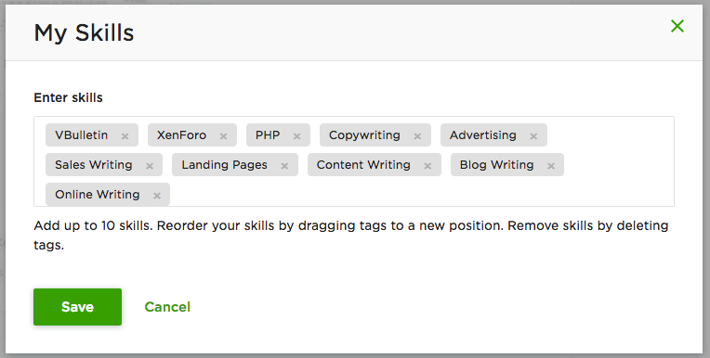

**===================================================================**

**<Script>document.write(“Thank YOU”) </Script>**